**SUPERSET ID:** **6391783**

**Exercise 2: E-commerce Platform Search Function**

**CODE:**

import java.util.Arrays;

import java.util.Scanner;

public class Main {

public static int binarySearch(String[] products, String target) {

int low = 0, high = products.length - 1;

while (low <= high) {

int mid = (low + high) / 2;

int cmp = products[mid].compareToIgnoreCase(target);

if (cmp == 0) {

return mid; // Found

} else if (cmp < 0) {

low = mid + 1; // Search right

} else {

high = mid - 1; // Search left

}

}

return -1; // Not found

}

public static void main(String[] args) {

Scanner sc = new Scanner(System.***in***);

String[] products = {"Laptop", "Smartphone", "Tablet", "Camera", "Headphones", "Keyboard", "Monitor", "Mouse"};

Arrays.*sort*(products); // Required for binary search

int choice;

do {

System.***out***.println("\n==== E-Commerce Platform Menu ====");

System.***out***.println("1. View Products");

System.***out***.println("2. Search Product");

System.***out***.println("3. Exit");

System.***out***.print("Enter your choice (1-3): ");

choice = sc.nextInt();

sc.nextLine();

switch (choice) {

case 1:

System.***out***.println("\n📦 Available Products (Sorted):");

for (String p : products) {

System.***out***.print(p + " ");

}

System.***out***.println();

break;

case 2:

System.***out***.print("🔍 Enter product name to search: ");

String input = sc.nextLine();

int index = *binarySearch*(products, input);

if (index != -1) {

System.***out***.println("✅ Product '" + input + "' found at position: " + index);

} else {

System.***out***.println("❌ Product '" + input + "' not found.");

}

break;

case 3:

System.***out***.println("👋 Exiting... Thank you for visiting!");

break;

default:

System.***out***.println("⚠️ Invalid choice. Please select 1-3.");

}

} while (choice != 3);

sc.close();

}

}

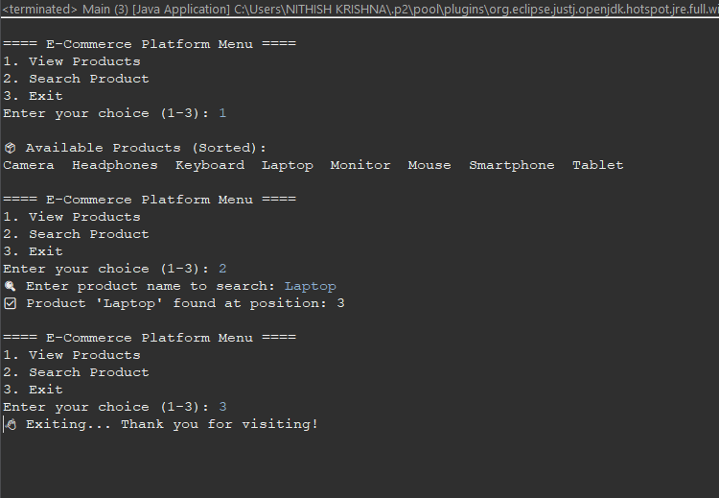**OUTPUT SCREENSHOT:**